Bash scripting task_12

1:)Create a bash script to check if a directory is available or not.

I execute the 2 times, one exists, and 2nd time does not exist

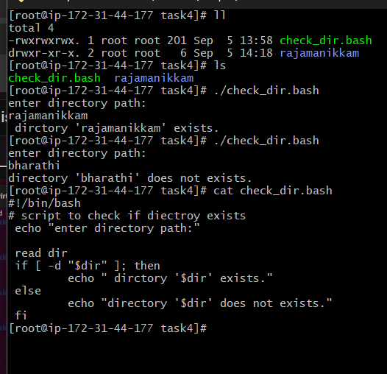

#!/bin/bash

# Script to check if a directory exists

# Ask user for directory path

echo "Enter directory path:"

read dir

# Check if directory exists

if [ -d "$dir" ]; then

echo "✅ Directory '$dir' exists."

else

echo "❌ Directory '$dir' does not exist."

fi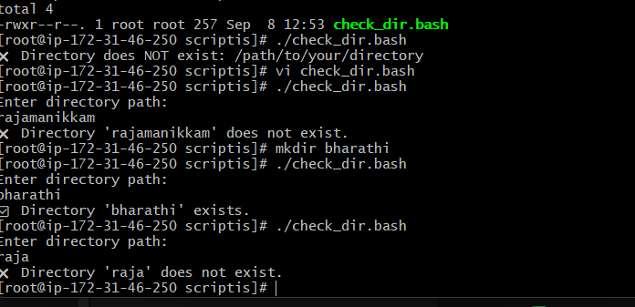

2) Create multiple files using bash scripts

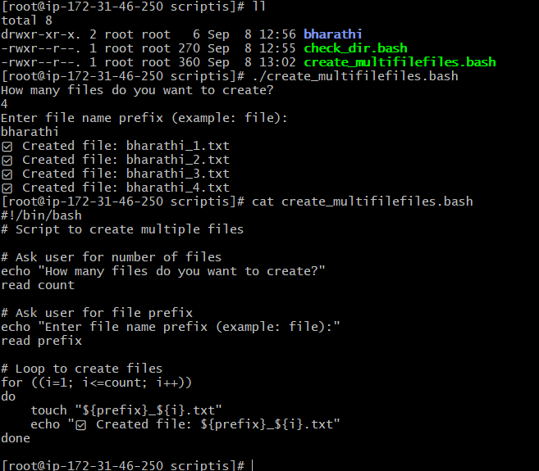

3)Create a bash script to take a backup of a directory.

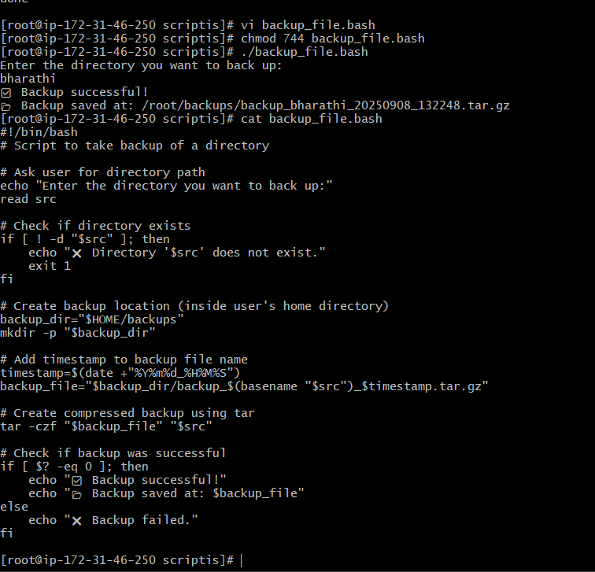

4)Create a bash script to install Nginx on an EC2 server.

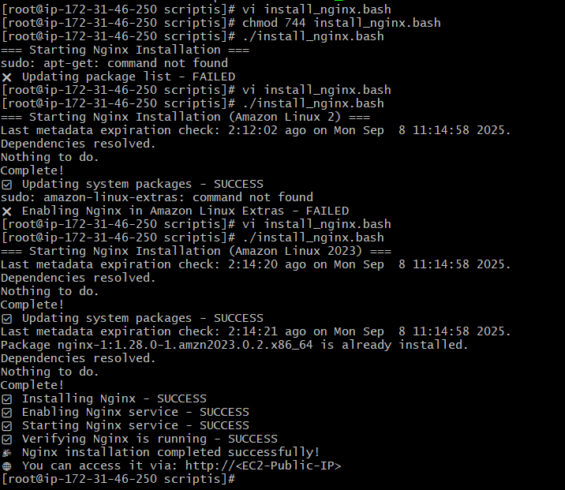

5)Create a bash script to install Apache Tomcat on an EC2 server.

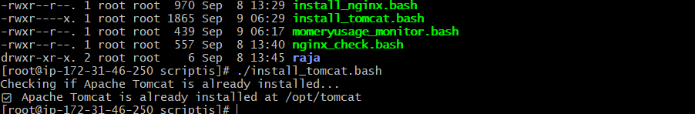

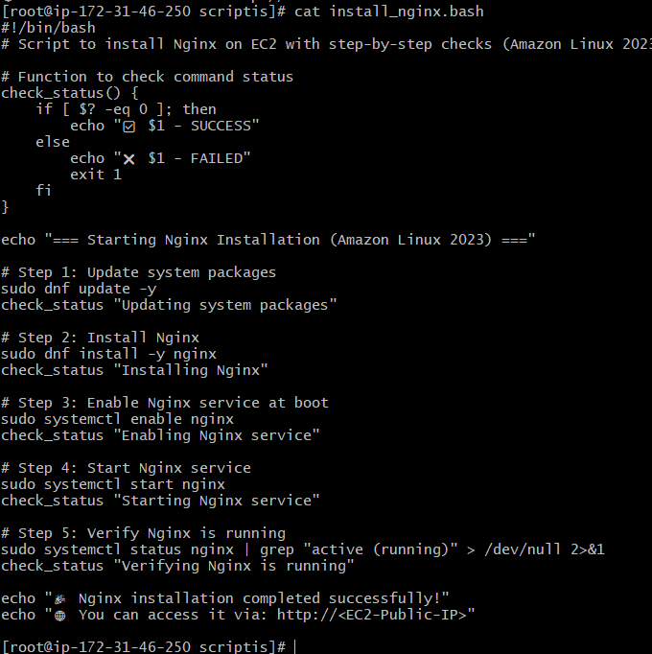

6)Create a bash script to check if the Nginx service is running, if not running then script should start the service.

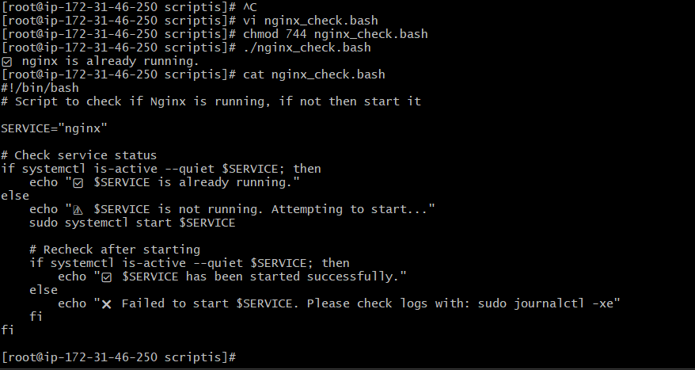

7)Create a bash script for a calculator.

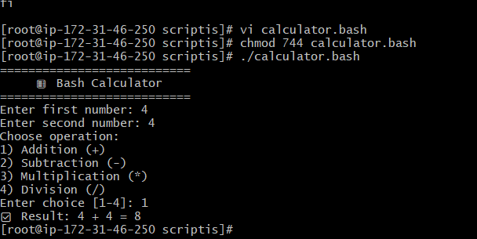

8)Create a bash script to check if a directory exists, if not then create a directory.

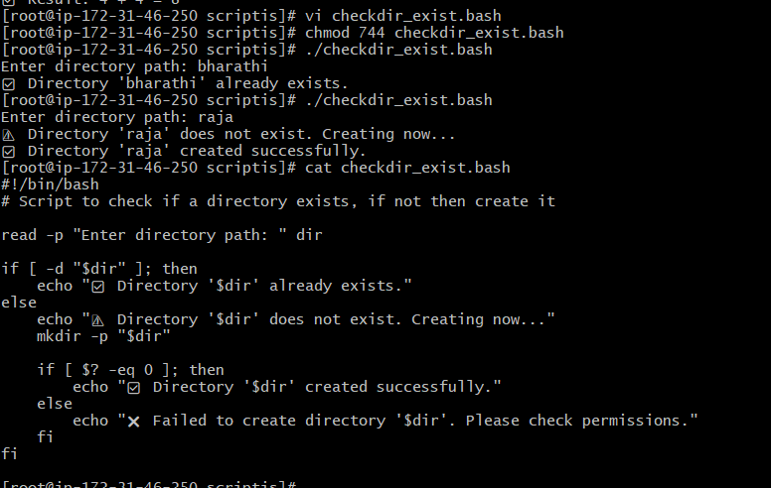

9) Create a bash script to delete the last 3 lines of a file.

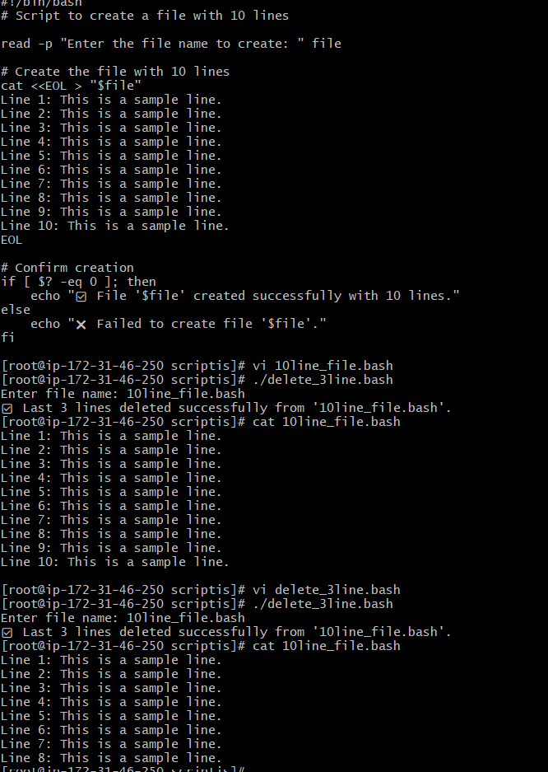

**10)Bash script to monitor cpu and if it is more than 80% then send email notification.**

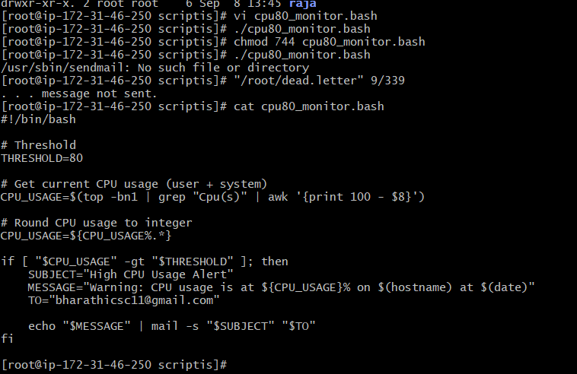

11)Bash script to monitor disk space and if it is more than 80% then send email notification.

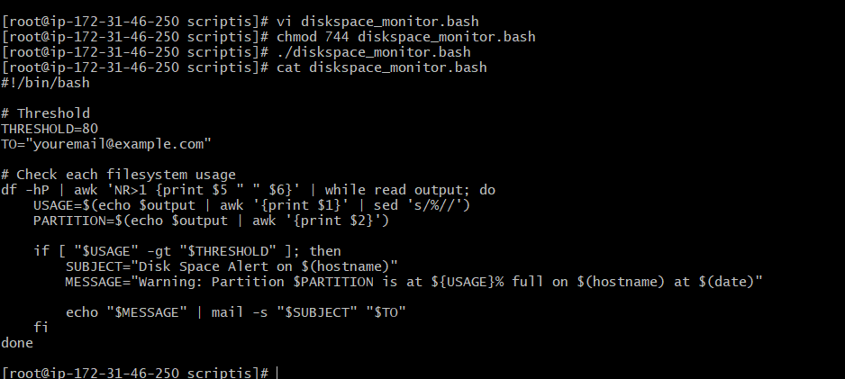

12)Bash script to monitor memory and if it is more than 80% then send email notification.

